COVID-19 Testing Prior to your Procedure
- Methodist McKinney Hospital requires a negative COVID-19 lab test prior to your procedure. Methodist Craig Ranch Surgery Center does not require COVID testing if patient has been COVID vaccinated.
- Please visit the hospital campus drive-thru for testing one day prior to your surgery day.
- LOCATION: Methodist McKinney Hospital 8000 W. Eldorado Pkwy., McKinney, TX, 75070
- DRIVE-THRU: Patients will visit the drive thru for testing, located on south side of hospital. Directional signs are posted throughout the campus starting at entrance of hospital off Eldorado Pkwy. (see map below)
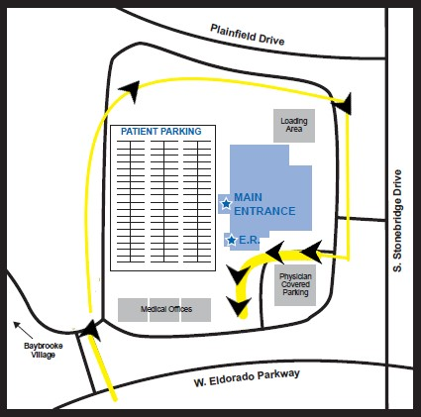
- DRIVE-THRU HOURS:
Monday -Thursday: 5:00 am - 5:00 pm
Sunday: 12:00 pm - 5:00 pm

To enter the covid testing drive-thru line,
please follow the yellow outline
in the direction of the arrows.

A nurse will contact you approximately 2-3 business days prior to your scheduled surgery day to discuss your medical history, current medications, pre-op instructions as well as remind you to visit the Covid testing drive-thru the day prior to your procedure.

For your convenience, the facility will send you friendly text messages with reminders and information concerning your procedure. For this reason, it is important to share your mobile number with your physician office if you wish to participate in this service.

Thank you and we look forward to caring for you.
Methodist McKinney Hospital | PAT contact information: 972-569-2751
Methodist Craig Ranch Surgery Center | PAT contact information: 469-907-1650 opt 2

